**Topics: Descriptive Statistics and Probability**

1. Look at the data given below. Plot the data, find the outliers and find out $μ, σ, σ^{2}$

|  |  |
| --- | --- |
| **Name of company** | **Measure X** |
| Allied Signal | 24.23% |
| Bankers Trust | 25.53% |
| General Mills | 25.41% |
| ITT Industries | 24.14% |
| J.P.Morgan & Co. | 29.62% |
| Lehman Brothers | 28.25% |
| Marriott | 25.81% |
| MCI | 24.39% |
| Merrill Lynch | 40.26% |
| Microsoft | 32.95% |
| Morgan Stanley | 91.36% |
| Sun Microsystems | 25.99% |
| Travelers | 39.42% |
| US Airways | 26.71% |
| Warner-Lambert | 35.00% |

**Ans=**

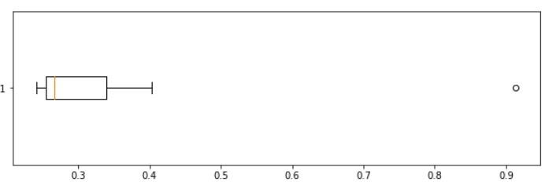

**The outlier is Morgan Stanley (91.36%)**

**Mean: 0.3327**

**Standard Deviation:0.1694**

**Variance:0.02871**



Answer the following three questions based on the box-plot above.

1. What is inter-quartile range of this dataset? (please approximate the numbers) In one line, explain what this value implies.

Ans:

Approximately (First Quantile Range) Q1 = 5 ( Third Quantile Range) Q3 = 12 ,

Median ( Second Quartile Range) IQR = Q3 – Q1 = 12 – 5 = 7

Second Quartile Range is the Median Value .

1. What can we say about the skewness of this dataset?

**Ans:**

The data set is Right-Skewed as the median is towards the left side .

1. If it was found that the data point with the value 25 is actually 2.5, how would the new box-plot be affected?

Ans:

In the above mentioned case there is no Outlier on the given dataset because

Of that the data will Normal Distributed.



Answer the following three questions based on the histogram above.

1. Where would the mode of this dataset lie?

Ans: The mode of this data set will be in between 4 to 8.

1. Comment on the skewness of the dataset.

Ans: Right-Skewed. Mean>Median>Mode

1. Suppose that the above histogram and the box-plot in question 2 are plotted for the same dataset. Explain how these graphs complement each other in providing information about any dataset.

Ans: They both are Right-skewed and both have outlier the median can be easily visualize in Box plot where as in histogram mode is more visible.

1. AT&T was running commercials in 1990 aimed at luring back customers who had switched to one of the other long-distance phone service providers. One such commercial shows a businessman trying to reach Phoenix and mistakenly getting Fiji, where a half-naked native on a beach responds incomprehensibly in Polynesian. When asked about this advertisement, AT&T admitted that the portrayed incident did not actually take place but added that this was an enactment of something that “could happen.” Suppose that one in 200 long-distance telephone calls is misdirected. What is the probability that at least one in five attempted telephone calls reaches the wrong number? (Assume independence of attempts.

**Ans=Ans:**

**Number of Calls(n) = 5, p = 1/200, q = 199/200**

**P(x) = at least one in five attempted telephone calls reaches the wrong number**

**P(x) = ⁿCₓ pˣ qⁿ⁻ ˣ**

**P(x) = (nCx) (p^x) (q^n-x)**

**P(x) = (5C1) (1/200)^1 (199/200)^5-1**

**P(x) = 0.0245037**

1. Returns on a certain business venture, to the nearest $1,000, are known to follow the following probability distribution

|  |  |
| --- | --- |
| x | P(x) |
| -2,000 | 0.1 |
| -1,000 | 0.1 |
| 0 | 0.2 |
| 1000 | 0.2 |
| 2000 | 0.3 |
| 3000 | 0.1 |

1. What is the most likely monetary outcome of the business venture?
2. Is the venture likely to be successful? Explain
3. What is the long-term average earning of business ventures of this kind? Explain
4. What is the good measure of the risk involved in a venture of this kind? Compute this measure

**Ans=i) Most likely monetary outcome of the business venture is 2000**

**It maximum probability is 0.3**

**ii) P(x>0) = 0.6, implies there is a 60% chance that the venture would yield profits**

**or  greater than expected returns. So the venture is likely to be successful.**

**iii) Weighted average = x*P(x) = 80%. This means the average expected earning**

**over a long period of time would be 800(including all losses and gains over the**

**period of time).**

**P(Incurring loss) = P(x= -2000)+P(x=-1000)=0.2. So the risk associated with venture is 20%**